## **Overview**

In this activity, you’ll practice aligning CSS Flexbox items inside parent containers.

Note: CSS Flexbox has powerful features that allow designers and developers to easily center and align content. Being able to use these features will be essential as you design and mock up complex and responsive designs.

## **Instructions**

1. Open the file index.html.
   * It’s located in the Unit 18 Activities folder, inside **18.1_activities.zip**.
   * This file includes parent containers with child elements.
2. When you open it in your browser, take notice of what it’s missing.
   * *Hint: None of the flex children are aligned inside their container.*
3. Open the index.css file located in Activities/02_Sizing_With_Flex_Items/css and add the align-items property to the .alignItems selector.
4. Set the value for align-items property to center.
5. Save your files and refresh index.html in your browser.
6. Change the value for align-items to flex-end or flex-start to see the differences that each value creates.
7. Add the justify-content property to the .justifyContent selector.
   * Try out the different values listed [here](https://developer.mozilla.org/en-US/docs/Web/CSS/justify-content) and see what they do to your content.
8. Lastly, add properties to the .perfectlyCentered selector to center the child element.
   * *Hint: You will need to use both align-items and justify-content.*
9. Your finished design should look like the image below:

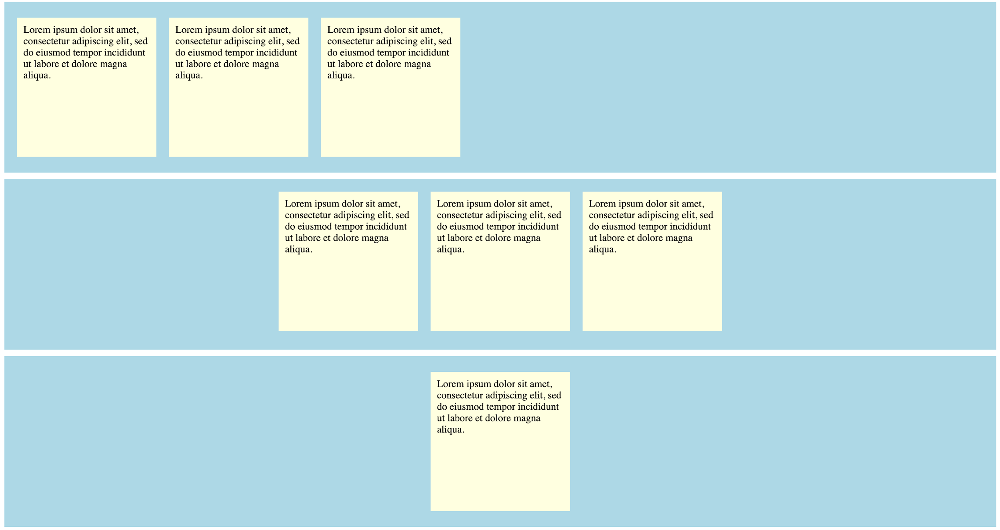

## **Resources**

If you get stuck, take a look at the resources for [align-items](https://developer.mozilla.org/en-US/docs/Web/CSS/align-items) and [justify-content](https://developer.mozilla.org/en-US/docs/Web/CSS/justify-content).